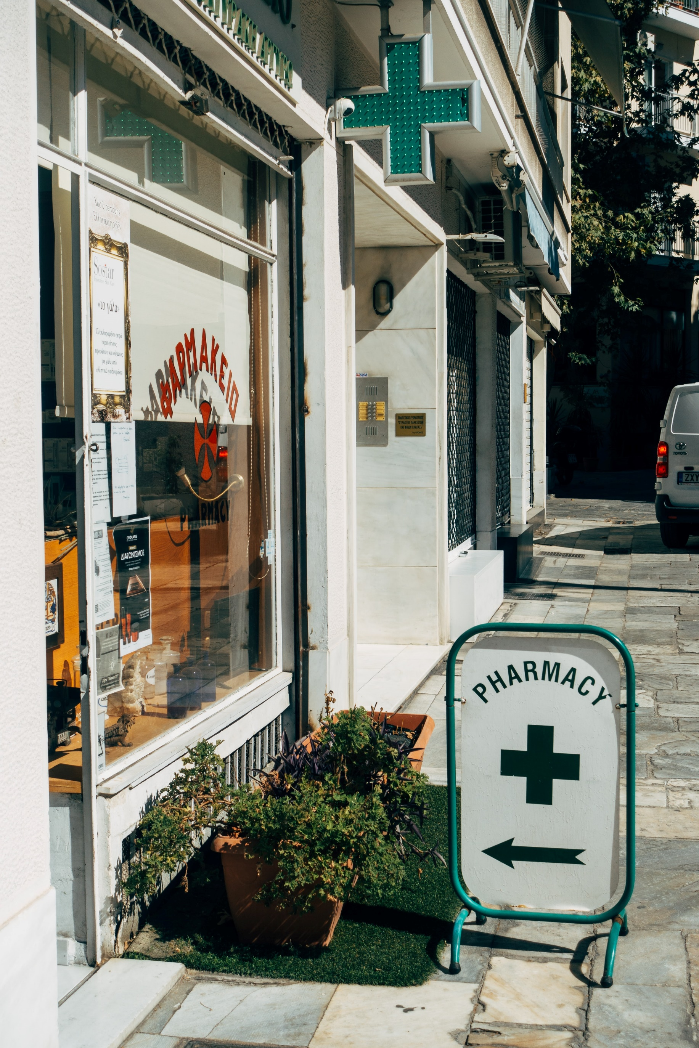

|  |
| --- |
| CARING PHARMACY |
| Business Process Management Project |
| 6 June  Carolina Rocha R20170740  Mariana Martins R20170804  Mariana Bailão R20170780  João César M20200669 |

**Index**

Introduction 3

Organizational Structure 3

Process Identification 3

AS-IS Process Model 4

Receive Client 4

Enter and Check Prescription 4

Fulfill Order 6

Deliver and Payment 7

Qualitative Analysis 8

Value-Added Analysis 8

Receive Client 8

Enter and Check Prescription 9

Fulfill Order 9

Deliver and Payment 9

Waste Analysis 10

Receive Client 10

Enter and Check Prescription 10

Fulfill Order 11

Deliver and Payment 11

Issue Register Analysis 11

Quantitative Analysis 13

Simulation 15

What-If Analysis 17

Process Redesign 20

Simulation TO-BE 21

Implementation Plan 26

Limitations 26

Conclusion 27

# Introduction

Caring Pharmacy is a Portuguese pharmacy that is in business since 1998. It has several stores, located in Porto, Faro, Coimbra, Santarém, Torres Vedras, Braga, Évora and Lisbon. The company has more than 80 employees, working in diverse departments, from technicians to pharmacists.

Currently, it has been registering some problems with its business process, considerer inefficient and slow. Also, sometimes the number of employees is not enough to serve every customer between the opening hours. This reality leads to customer dissatisfaction, and consequently, poor reputation.

The objective is to improve the order-to-cash process of the pharmacy of Lisbon, which includes “Receive Client”, “Enter and Check Prescription”, “Fulfill order”, and “Deliver and Payment” sub- processes, to increase the efficiency and, this way, increasing the customers and employee satisfaction.

Both AS-IS and TO-BE process models proposed will be done using the Business Process Model Notation (BPMN) with the help of Bizagi Modeler.

# Organizational Structure

In this project, we are going to focus on the pharmacy located in Lisbon. The store is open from 10 am to 6 pm and has around 220 customers per day. It has seven employees (four technicians and three pharmacists).

# Process Identification

In this BPM project, we will analyze the Order-to-cash (O2C) process of the Caring Pharmacy of Lisbon. This process has four sub-processes: receive the client, enter and check the prescription, fulfill the order, and, finally, deliver and payment.

An Order-to-cash process is the business process that covers all the inter-related events, activities, and decision points from receiving the order to receiving the payment, creating value for the customer.

The process in which we are focusing on this project starts with an event, a client entering the pharmacy making an order. Then involves a set of activities and decisions executed by the technicians and pharmacists to fulfill the order and please the customers, creating value to them and retrieving business value to the company.

# AS-IS Process Model

## Receive Client

AS-IS Description

The process begins when a client enters the pharmacy. First, the technician requests the order and checks if the client has a medical prescription for the order that is placing. If the customer has a medical prescription either in paper or in a message on the phone the technician registers the order in the database. When the customer has no medical prescription, the technician takes note of the order and then proceeds to check in the system if the order can be placed without a medical prescription. If the drugs ordered do not need a prescription, the technician registers the order, if not the order is cancelled, and the client leaves the store without the medication.

AS-IS Model

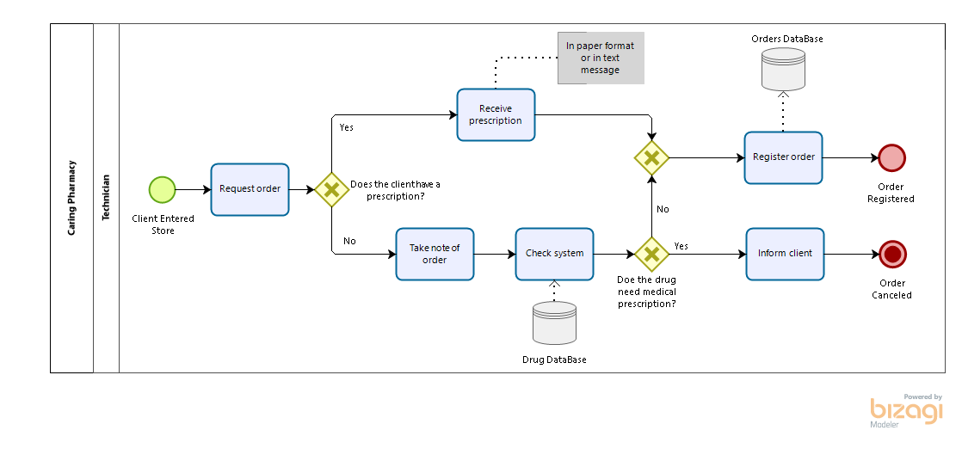

Figure 1- Receive Client AS-IS Model

## Enter and Check Prescription

AS-IS Description

The process starts with the technician receiving the prescription. Then enters its details on the pharmacy’s' system. The system will do the DUR (drug utilization review). If this system rings an alert, the prescription includes drugs that should not be taken together, so the pharmacist should not give both drugs to the client. The next step is to check the customers' history and see if usual for this customer to purchases both drugs together. If it is routine, after inserting a justification on the system, the process will move as if there were no alert. If it is the first time this happens, the pharmacist will have to call the clients' doctor and hope the doctor picks up the phone because, otherwise, the pharmacist will not be able to move forward with the process and will have to ask the client to come back another day. In case the doctor answers the call, the pharmacist needs to check if the doctor had made a mistake or if the prescription is correct. If a mistake has occurred, the doctor can send another prescription, or the client will have to come back another day. If the doctor stands correct, then this will be treated as if it was routine. The most common scenario is Drug Utilization Review system does not ring an alarm, and the process moves on from there. The next step is to check on the system if the clients' insurance covers the entire prescription. If so, the pharmacist informs the client that the order is fully covered by the insurance, and the prescription is checked. In case the insurance does not cover all drugs, the pharmacist will check if there are alternatives. If there are no alternatives, the pharmacist will inform the client and ask if he stills wants to make the order and pay the part not covered by the insurance. If there are alternatives, the pharmacist will need to call the clients' doctor and ask if the replacement is possible. If the clients' doctor answers the call and gives an affirmative answer, the pharmacist informs the client, and the new prescription is checked. If the doctor does not answer or provide a negative one, the pharmacist notifies the client and asks if he wants to pay for the drugs not covered by the insurance.

AS-IS Model

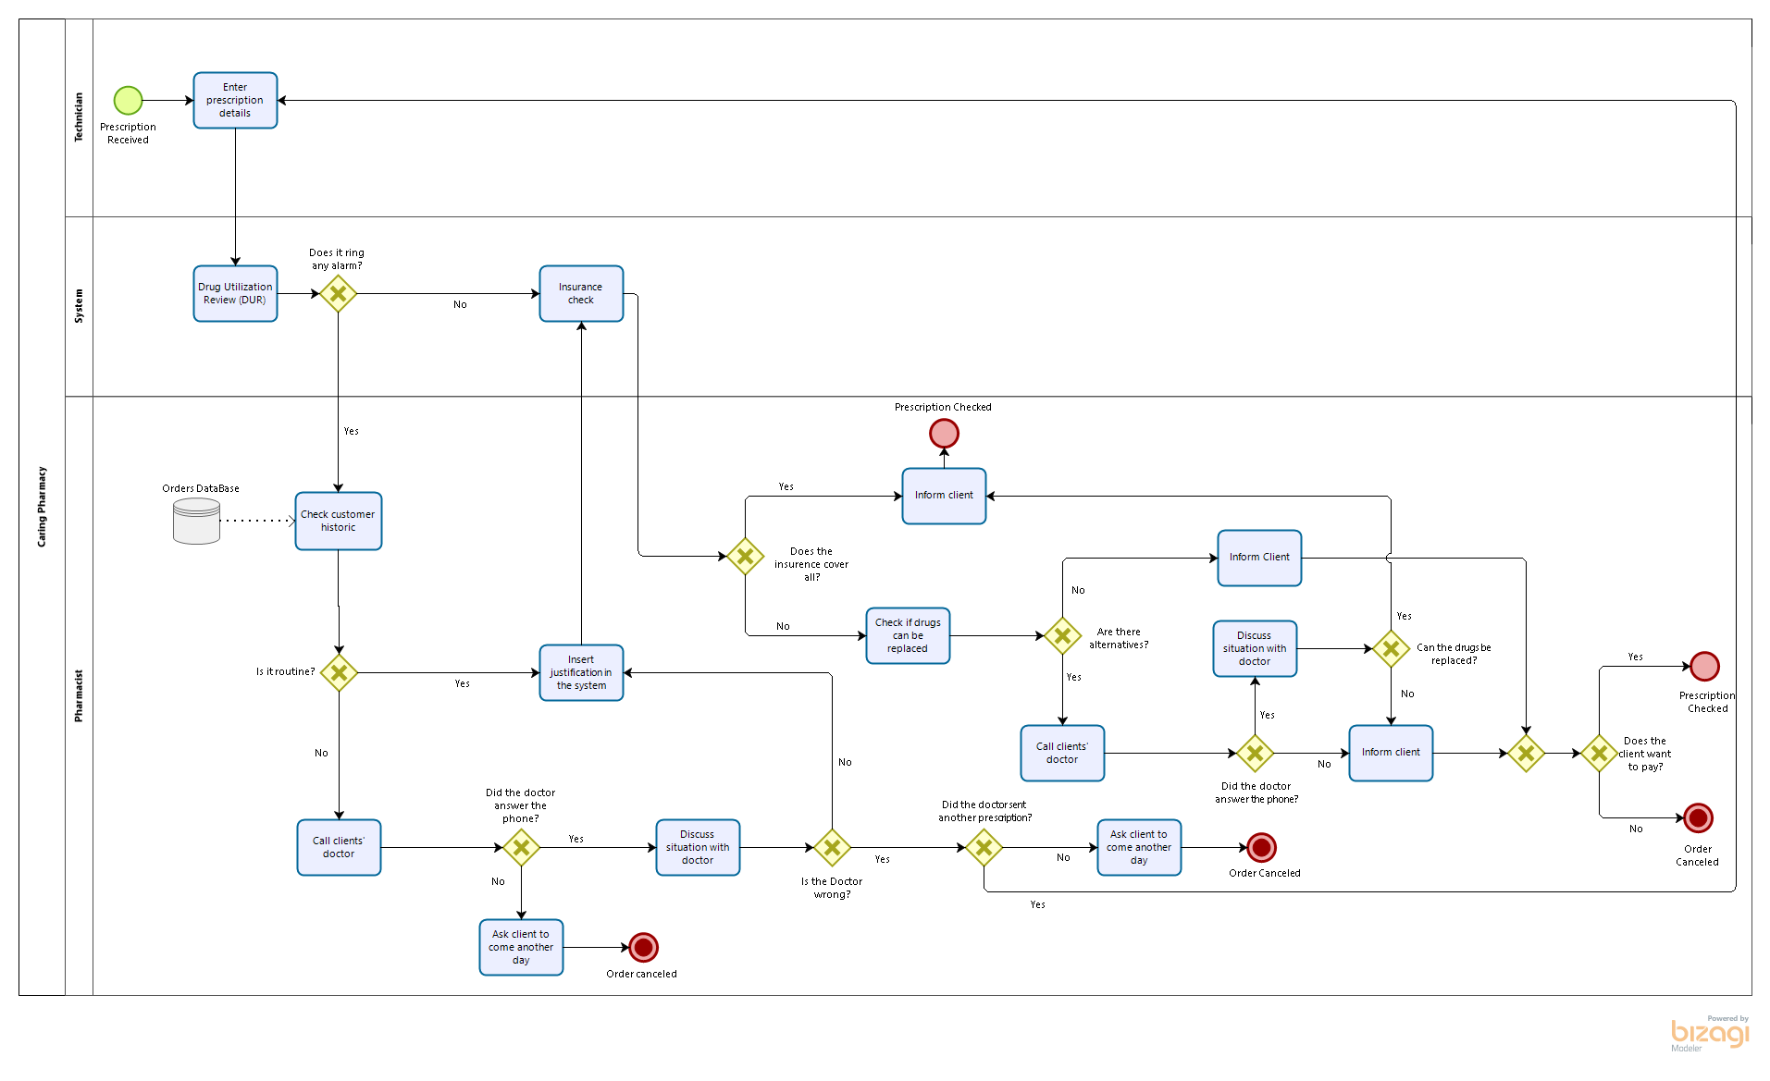

Figure 2- Enter and Check Prescription AS-IS Model

## Fulfill Order

AS-IS Description

This process starts with the technician checking if the pharmacy has in stock the medication required by the customer. If there is stock, the technician will get the medicine, and the pharmacist checks if it is correct. If it is correct, the technician packs it and finishes the purchase order. In the case the medication is incorrect, the instance returns to the beginning of the process. On the other hand, if there is no stock of the medication required, the technician will inform the pharmacist. Then the pharmacist will need to choose alternative medicine. If there are alternatives, the pharmacist chooses one and checks if it is necessary to talk with the clients' doctor. If it is not needed to call the doctor, the pharmacist discusses the options with the client, and if this agrees with the new option, the technician will get the medicine, the pharmacist checks it, and if it is correct, the technician packs it and finishes the purchase order. Otherwise, the process returns to the beginning. If it is needed to call the doctor, the pharmacist does it, and then the technician will get the medicine, the pharmacist checks it, and if it is correct, the technician packs it and finishes the purchase order. Otherwise, the process returns to the beginning.

In the case that does not exist an alternative, the pharmacist informs the technician. Then, the technician notifies the customer and asks the supplier for the missing medicine, hence ending the process.

AS-IS Model

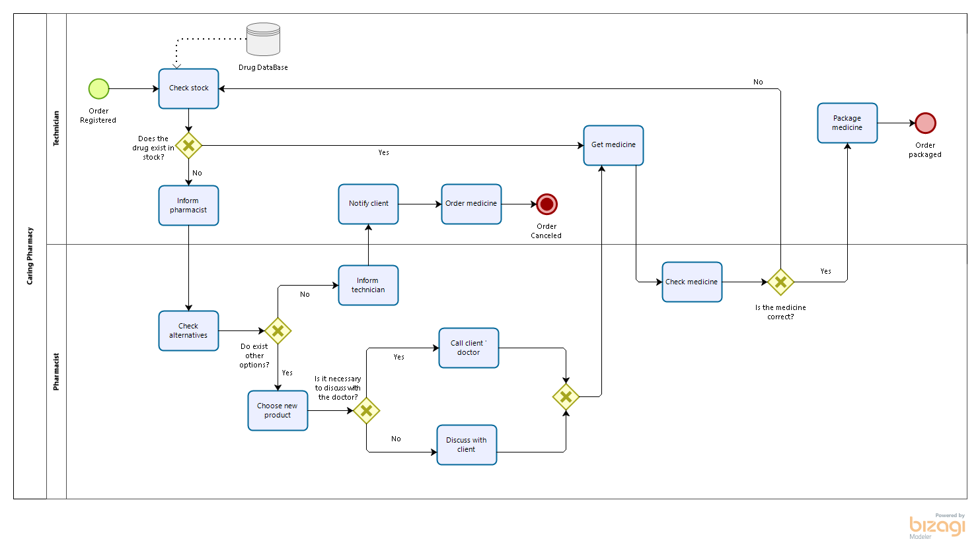

Figure 3 - Fulfill Order AS-IS Model

## Deliver and Payment

AS-IS Description

Once the order is packaged, the last sub-process starts. The technician receives the payment and delivers the respective order to the customer. This will be followed by the client leaving the store what represents the end of the process.

AS-IS Model

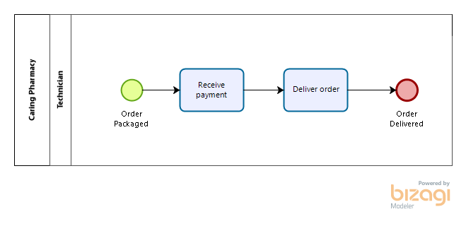

Figure 4 - Deliver and Payment AS-IS Model

# Qualitative Analysis

In this type of analysis, we will do the value-added analysis, the waste analysis, and the issue register.

## Value-Added Analysis

The value-added analysis aims to detect unnecessary steps in a process with the intention of eliminating them. We can identify which steps or tasks, carried out throughout the process, bring value or not to the client and/or the business. By doing this, we can later make the process more efficient and faster. We can classify the steps into three categories:

* Value Adding (VA): Steps that directly contribute to positive results. It focuses, particularly on the customer since it is defined as when the customer agrees to pay for the step in question and agrees to continue to conduct business with the company.
* Business Value Adding (BVA): Steps that do not directly bring value to the customer, but are necessary for the business to run efficiently, to collect revenue, or to improve or grow the business. These steps would be harmful if removed since they represent tasks that reduce the risk of business losses and sometimes are required for the company to comply with regulatory requirements.
* Non-Value Adding (NVA): Steps that do not increase the worth of what is delivered to the customer. All steps considered NVA tend to negatively influence the business since they increase the waste of time and, consequently increase the dissatisfaction, not only of the customers, but also of the employees.

The goal of this analysis is to minimize BVA and eliminate NVA as much as possible, to make the process more efficient and faster.

### Receive Client

|  |  |  |
| --- | --- | --- |
| STEPS | PERFORMER | CLASSIFICATION |
| Request order | Technician | BVA |
| Receive prescription | Technician | BVA |
| Take note of order | Technician | BVA |
| Check system | Technician | BVA |
| Register order | Technician | VA |
| Inform client | Technician | VA |

Figure 5 - Receive Client Value-Added Analysis

### Enter and Check Prescription

|  |  |  |
| --- | --- | --- |
| STEPS | PERFORMER | CLASSIFICATION |
| Enter prescription details | Technician | BVA |
| Drug Utilization Review (DUR) | System | BVA |
| Insurance check | System | BVA |
| Check customer historic | Pharmacist | BVA |
| Call clients’ doctor | Pharmacist | VA |
| Insert justification in the system | Pharmacist | NVA |
| Check if drugs can be replaced | Pharmacist | BVA |
| Discuss situation with doctor | Pharmacist | VA |
| Inform client that insurance covers all | Pharmacist | VA |
| Ask client to come another day | Pharmacist | VA |

Figure 6 - Enter and Check Prescription Value-Added Analysis

### Fulfill Order

|  |  |  |
| --- | --- | --- |
| STEPS | PERFORMER | CLASSIFICATION |
| Check stock | Technician | BVA |
| Inform pharmacist | Technician | NVA |
| Get medicine | Technician | BVA |
| Notify client | Technician | NVA |
| Order medicine | Technician | BVA |
| Package medicine | Technician | VA |
| Check alternatives | Pharmacist | VA |
| Inform technician | Pharmacist | NVA |
| Choose new product | Pharmacist | VA |
| Check medicine | Pharmacist | BVA |
| Call clients’ doctor | Pharmacist | VA |
| Discuss with client | Pharmacist | VA |

Figure 7 – Fulfill Order Value-Added Analysis

### Deliver and Payment

|  |  |  |
| --- | --- | --- |
| STEPS | PERFORMER | CLASSIFICATION |
| Receive payment | Technician | BVA |
| Deliver order | Technician | VA |

Figure 8 - Deliver and Payment Value-Added Analysis

## Waste Analysis

The Waste Analysis intends to find “waste” throughout processes. Wastes are subsequently grouped into three categories:

* Move: Waste related to movement. This category includes two sub-types of waste:
* Transportation- Send or receive materials or documents (incl. electronic) taken as input or output by the process activities.
* Motion- Motion of resources internally within the process. Common in manufacturing processes, less common in-service processes.
* Hold: Waste arising from holding something. Again, this category includes two subtypes of waste:
* Inventory- Materials inventory and Work-in-process (WIP).
* Waiting- Task waiting for materials or input data. Task waiting for a resource. Resource waiting for work (aka resource idleness).
* Overdo: Waste arising from doing more than is necessary to deliver value to the customer or the business. This category encompasses three sub-types of waste:
* Defects- Correcting or compensating for a defect or error. Rework loops.
* Overprocessing- Tasks performed unnecessarily given the outcome of the process and unnecessary perfectionism.
* Overproduction- Unnecessary process instances are performed, producing outcomes that do not add value upon completion.

### Receive Client

|  |  |  |
| --- | --- | --- |
|  | **TYPE OF WASTE** | **ACTIVITY** |
| **MOVE** | Transportation | Receive Prescription |
| Motion |  |
| **HOLD** | Waiting |  |
| Waiting for a customer to arrive  Waiting for the system |

Figure 9 - Receive Client Waste Analysis

### Enter and Check Prescription

|  |  |  |
| --- | --- | --- |
|  | TYPE OF WASTE | ACTIVITY |
| MOVE | Transportation | Insert note in the system  Insert details in DUR |
| Motion | Inform client |
| HOLD | Waiting | Package medicine  Call doctor  Wait for historic verification  Wait for DUR |
| OVERDO | Defects | Ask client to come in another day, due to doctor error  New electronic prescription after calling the doctor |

Figure 10 - Enter and Check Prescription Waste Analysis

### Fulfill Order

|  |  |  |
| --- | --- | --- |
|  | TYPE OF WASTE | ACTIVITY |
| MOVE | Transportation | Get medicine |
| Motion | Technician informs pharmacist  Pharmacist informs technician |
| HOLD | Waiting | Call doctor  Wait for stock checking |
| OVERDO | Defects | Check medicine (if wrong) |
| Overprocessing | Check medicine (if correct) |

Figure 11 - Fulfill Order Waste Analysis

### Deliver and Payment

|  |  |  |
| --- | --- | --- |
|  | TYPE OF WASTE | ACTIVITY |
| MOVE | Transportation | Receive payment  Deliver order |
| HOLD | Waiting | Wait for payment |

Figure 12- Deliver and Payment Waste Analysis

## Issue Register Analysis

This analysis has as goal maintain, organize, and prioritize identified issues and weaknesses of the company. The analysis will allow us to determine which problems affect the company directly, as well as the factors that are the basis of these problems. To do this, it is necessary to organize and prioritize these problems, provide details in the analysis to identify factors that may not be directly in view, and finally determine in which measures and how these factors are affecting the processes and which from Caring Pharmacy.

|  |  |  |  |  |  |
| --- | --- | --- | --- | --- | --- |
| ISSUE | PRIORITY | DESCRIPTION | DATA AND  ASSUMPTIONS | QUALITATIVE IMPACT | QUANTITATIVE IMPACT |
| Waiting time | 5 | When a client arrives at the pharmacy he must wait in a queue. | Not mentioned | Can lead to client dissatisfaction. | Impact in the company profit if the client decides to do leave due to big waiting time or if they cannot be attended. |
| Not answered calls | 3 | When the pharmacist calls the doctor sometimes, he does not pick up. | 40% of the time | Can lead to client dissatisfaction because the customer can leave and return another day. | Direct impact in the company profit. |
| Call duration with doctor | 3 | Calling the clients’ doctor takes too long | 5 minutes | Can lead to client dissatisfaction since it takes too long for the customer being served and increases the waiting queue. | When serving a single customer, the pharmacist might have the need to call the doctor up to three times. The duration of said calls directly affects the average time spent per customer, which reduces the pharmacy’s overall ability to serve more customers. This diminishes profits greatly. |
| Poor control of stock levels | 1 | When there is no stock so that there is no shortage of medicines when needed. This implies, the client must return in another day. | The medicine is only available 75% of the cases. Besides this, ordering it  from supplier takes on average 1.5 minutes. | The image of the company ends up being damaged since the buying process instead of taking a few minutes, takes days. Therefore, the customers can end giving up the purchase. | The profit of the pharmacy decreases once customers give up on the purchase if it is urgent. This will lead them to change pharmacy for a more efficient one and, finally, the time spent on solving previous purchases is a waste since it does not allow an increase of the profit, as new customers are not being served. |
| Unnecessary repetition of the medicine verification | 2 | The pharmacist needs to check if the medicine is correct even when it was previously checked. | The medicine is correct 95% of the times and verification take 30 seconds. | It is an inefficient allocation of pharmacist’s time, called “Over Processing”, once it is considered an unnecessary perfectionism due to the percentage of times that is correct. | The profit of the pharmacy may decrease once customers are losing their time and they might look for another pharmacy more efficient in the future. |

Figure 13 - Issue Register

# Quantitative Analysis

This analysis will focus on one very important process performance measure - time. Our main goal is to analyze how much each process, on average, takes to be completed and what we can do to improve the cycle time efficiency. Besides, we will analyze resource utilization which is the ratio between time spent on process work and time available per resource for process work.

To calculate the duration of each task, the probability of each activity/situation, the distribution of the various events and activities, assign the resources, as well as their costs, define calendars, among other tools, we performed a quantitative analysis through Bizagi business process modeling software, more precisely with the Process Simulation tool.

To perform this analysis, we modeled an AS-IS of the whole process of the Caring Pharmacy and worked on it.

This model is a combination of all the other four AS-IS that we modeled with a slight change. The sub-process Enter and Check Prescription is only necessary when the customer has a prescription so we had to add this to this process. To be easier to read and analyze we also created sub-processes of all the activities that were followed by activities and were performed by the same person, meaning that they were in the same lane.

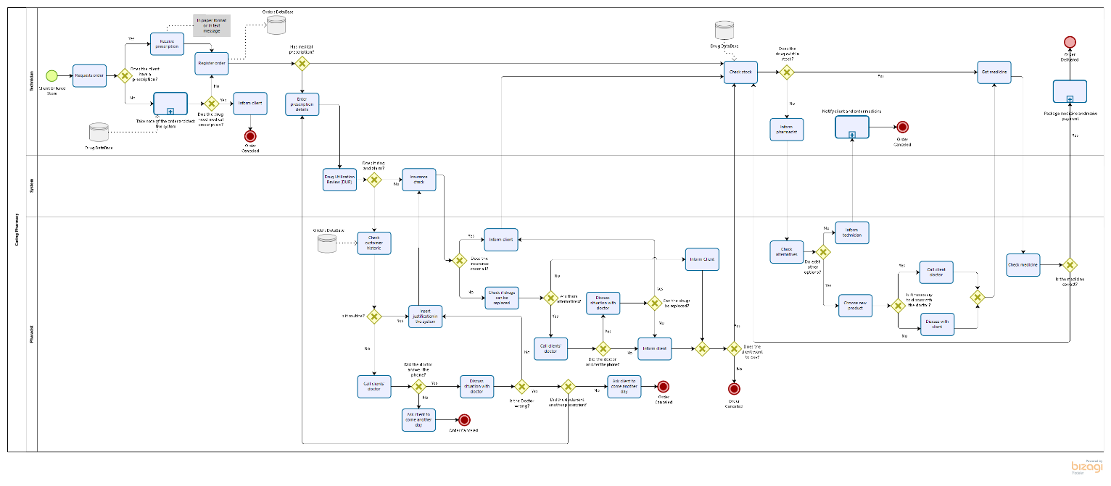

Figure 14 - Caring Pharmacy AS-IS Model

## Simulation

To build and run the simulations of the model we designed we used the data provided by the company. We considered that the pharmacy is open every day, from 10 AM to 6 PM (8 hours), and receives 220 customers per day.

The simulation is divided into 4 levels:

1. **Process Validation**

It is the first level of the simulation and is the one responsible to evaluate the structure of the process workflow. Here we ensured that everything was synchronized, defined the probabilities for the gateways, the number maximum of arrivals (220).

1. **Time Analysis**

The next step was to perform a time analysis by assigning average times to each activity in the AS-IS model, defining the distribution, the maximum and minimum, and the standard deviation. Since Bizagi has some rules-to do the simulation of a model, we have defined the following:

* + For the start event, we used the Poisson distribution because it represents the probability of a certain event to occur in a certain amount of time when the events occur independently from each other.
  + For all activities, we used Truncated Normal Distribution because all these were repetitive tasks, that have an average time for execution but the equal probability of taking more, or less, time.

Regarding the start event, with the Poisson distribution, we need to calculate the average. This is done depending on the instances that are completed in the previous process and that arrive at this new event.

Mean Arrival rate (λ)= Total Arrivals per Day/ Total Time of the Workday (in min) = 220/480= 0,4583(3)

Mean Inter-Arrival Time= 1/ λ= 1/0,4583= 2,182

* + This means that every 2 minutes and 22 seconds a new client enters the pharmacy.

1. **Resource Analysis**

The third level is to assign each activity to one or more different employees, or systems. In our project, we are working with 4 technicians, 3 pharmacists, and 1 system. For the system, we had no information but we assumed that the whole pharmacy works with the same system even if each of the employees has their computer. This analysis allows us to evaluate the under or overuse of resources, the total cost of resources and activities and shows the most accurate execution cycle. For this specific project, by following the teachers’ guidelines we did not define the cost of the resources.

This process for each client, involves 1 technician, 1 pharmacist, and 1 system.

|  |  |  |  |  |  |  |  |  |
| --- | --- | --- | --- | --- | --- | --- | --- | --- |
| **Name** | **Type** | **Instances Completed** | **Instances Started** | **Min. Time** | **Max. Time** | **Avg. Time** | **Total Time** | **Total Time Waiting Resource** |
| Caring Pharmacy | Process | 140 | 220 | 1m 6s | 18m 14s | 8m 29s | 19h 49m 37s | 31m 7s |

After all this, we proceed to execute the simulation of the process and we obtained the following results. To note that the average time can be a bit bigger than the one proposed on the handout of the project because we, as a group, made several assumptions that have an impact on the model average time, like the fact that even though is not stated we consider that every time the order is canceled for whatever reason the technician, or the pharmacist must inform the client.

Figure 15 - Simulation Results

|  |  |
| --- | --- |
| **Resource** | **Utilization** |
| Pharmacist | 35,16% |
| Technician | 33,99% |
| System | 13,38% |

Figure 16 - Resource Utilization

From all the values that the simulation in Bizagi allow us to see we can extract some values that are more important:

* The average time is 8minutes and 29 seconds.
* We only complete the order of 140 of the 220 customers that enter our store.
* The activity that takes the longest in the company’s process is ‘Call the doctor’ with around 4 minutes every time is needed. This activity even though performed by an employee of the company is a little bit outside of the company control because is required to continue the process, but the doctor is an external person to the process.
* The resource utilization is very low.

## What-If Analysis

Based on our results from the simulations there are some conclusions we can take and with that built some new scenarios for the same model. We built six what-if scenarios to test if some changes could improve the current model and could be possible implementations for the TO-BE model.

Scenario 1: 3 technicians and 2 pharmacists

Since we understood that our resource utilization was very low our first tough was to fire 1 technician and 1 pharmacist. As we can see from the results the resource utilization went up as expected but the results in the process itself were negative since the average time was worsened by 1minute and 16 seconds. The total time waiting for the resource was incredibly worsened by almost 3 hours. So, we do not consider this a plausible scenario.

|  |  |  |  |  |  |  |  |  |
| --- | --- | --- | --- | --- | --- | --- | --- | --- |
| **Name** | **Type** | **Instances Completed** | **Instances Started** | **Min. Time** | **Max. Time** | **Avg. Time** | **Total Time** | **Total Time Waiting Resource** |
| Caring Pharmacy | Process | 140 | 220 | 1m 28s | 32m 52s | 9m 46s | 22h 47m 27s | 3h 28m 57s |

Figure 17 - Scenario 1 - Simulation Results

|  |  |
| --- | --- |
| **Resource** | **Utilization** |
| Pharmacist | 52,73% |
| Technician | 45,32% |
| System | 13,38% |

Figure 18 - Scenario 1 - Resource Utilization

Scenario 2: 4 technicians and 1 pharmacist

In this scenario, we tried to keep all the technicians we have and reduce the pharmacists to 1 only. The resource utilization for the pharmacists went up but too much up since it passed the 90% utilization. The average time of the process was too much to even consider this scenario, worsening to 40 minutes.

|  |  |  |  |  |  |  |  |  |
| --- | --- | --- | --- | --- | --- | --- | --- | --- |
| **Name** | **Type** | **Instances Completed** | **Instances Started** | **Min. Time** | **Max. Time** | **Avg. Time** | **Total Time** | **Total Time Waiting Resource** |
| Caring Pharmacy | Process | 140 | 220 | 1m 6s | 1h 48m 1s | 40m 17s | 3d 22h 41s | 3d 2h 42m 11s |

Figure 19 - Scenario 2 - Simulation Results

|  |  |
| --- | --- |
| **Resource** | **Utilization** |
| Pharmacist | 95,04% |
| Technician | 30,63% |
| System | 12,06% |

Figure 20 - Scenario 2 - Resource Utilization

Scenario 3: 2 technicians and 4 pharmacists

With the results from the last scenario, we understood that was impossible to reduce the pharmacists so much so we tried to reduce by half the technicians this time. The resource utilization of the technician is very much more adequate but very low for the pharmacist. The average time of the process was worse again, so was the total time waiting for a resource.

|  |  |  |  |  |  |  |  |  |
| --- | --- | --- | --- | --- | --- | --- | --- | --- |
| **Name** | **Type** | **Instances Completed** | **Instances Started** | **Min. Time** | **Max. Time** | **Avg. Time** | **Total Time** | **Total Time Waiting Resource** |
| Caring Pharmacy | Process | 140 | 220 | 1m 32s | 19m 17s | 9m 58s | 23h 17m 38s | 3h 59m 8s |

Figure 21 - Scenario 3 - Simulation Results

|  |  |
| --- | --- |
| **Resource** | **Utilization** |
| Pharmacist | 26,37% |
| Technician | 67,98% |
| System | 13,38% |

Figure 22- Scenario 3 - Resource Utilization

Scenario 4: 2 technicians and 3 pharmacists

Since in the last scenario we figured that 4 pharmacists were too much due to their resource utilization we fired one. This showed to not be enough in the resource utilization and worsen the average time to 10 minutes and 4 seconds, around a minute and a half worse than the original scenario.

|  |  |  |  |  |  |  |  |  |
| --- | --- | --- | --- | --- | --- | --- | --- | --- |
| **Name** | **Type** | **Instances Completed** | **Instances Started** | **Min. Time** | **Max. Time** | **Avg. Time** | **Total Time** | **Total Time Waiting Resource** |
| Caring Pharmacy | Process | 140 | 220 | 1m 32s | 19m | 10m 4s | 23h 31m 31s | 4h 13m 1s |

Figure 23 - Scenario 4 - Simulation Results

|  |  |
| --- | --- |
| **Resource** | **Utilization** |
| Pharmacist | 35,16% |
| Technician | 67,98% |
| System | 13,38% |

Figure 24 - Scenario 4 - Resource Utilization

Scenario 5: 2 technicians and 2 pharmacists

To try to achieve good resource utilization for the pharmacists we for another one in this scenario. As we can see the resource utilization was good at this point but for this, we sacrificed the average time of the process that is now 11 minutes and 2 seconds.

|  |  |  |  |  |  |  |  |  |
| --- | --- | --- | --- | --- | --- | --- | --- | --- |
| **Name** | **Type** | **Instances Completed** | **Instances Started** | **Min. Time** | **Max. Time** | **Avg. Time** | **Total Time** | **Total Time Waiting Resource** |
| Caring Pharmacy | Process | 140 | 220 | 1m 32s | 23m 1s | 11m 2s | 1d 1h 45m 14s | 6h 26m 44s |

Figure 25 - Scenario 5 - Simulation Results

|  |  |
| --- | --- |
| **Resource** | **Utilization** |
| Pharmacist | 52,73% |
| Technician | 67,98% |
| System | 13,38% |

Figure 26 - Scenario 5 - Resource Utilization

Scenario 6: 3 technicians and 3 pharmacists

To try to better the average time in our last scenario we added one of each, which compared to the original scenario, means firing only one technician. The resource utilization is acceptable, but the average time of the process worsens but not significantly, only 13 seconds from the original scenario. This is the only scenario that we think that the company could benefit from it because even though the time went up slightly it implies having to pay one less salary.

|  |  |  |  |  |  |  |  |  |
| --- | --- | --- | --- | --- | --- | --- | --- | --- |
| **Name** | **Type** | **Instances Completed** | **Instances Started** | **Min. Time** | **Max. Time** | **Avg. Time** | **Total Time** | **Total Time Waiting Resource** |
| Caring Pharmacy | Process | 140 | 220 | 1m 8s | 18m 19s | 8m 42s | 20h 18m 47s | 1h 17s |

Figure 27 - Scenario 6 - Simulation Results

|  |  |
| --- | --- |
| **Resource** | **Utilization** |
| Pharmacist | 35,16% |
| Technician | 45,32% |
| System | 13,38% |

Figure 28- Scenario 6 - Resource Utilization

# Process Redesign

After analyzing this process, it is clear that several activities are counter-productive and should be redesigned, to maximize the efficiency of the entire process of the Caring Pharmacy. We followed a transactional process redesign approach where we incrementally changed the AS-IS process. We then analyzed our new models based on redesign heuristics that strike trade-offs between the components of the Devil’s Quadrangle, cost, time, quality, and flexibility.

Our most significant change was the implementation of a new information system from Glintt, SIFARMA, a pharmacy management software. It is a business intelligence solution that improves the management of pharmacies by developing crucial work in stock management and the sales process of the pharmacy. One plus that was very important in our decision is that this system is an invaluable source of information. Contains the indication, dosage, adverse reactions, precautions, and interactions of each medicine, allowing personalized advice for each dispensed drug while ensuring its safe and correct utilization. Furthermore, it has the advantage of reading electronic medical prescriptions, allowing the pharmacist to keep track of patient history and detecting contraindications and not desired interactions between prescribed medicines.

To improve the solution, we also recommend the integration of a robot, the Rowa Vsmart. This solution will bring the pharmacy a multitude of benefits, such as improving customer satisfaction. While the robot gets the medicines ordered, the employee can give more attention to the patient, for example, making sure he/she understands the correct way and time of taking the drug. The robot will also help with inventory control, notifying the pharmacist (or the technician) when a specific drug gets below a certain stock level. Quality control and safety for the consumer will improve since the robots make fewer mistakes than the pharmacist. However, a double-check done by the pharmacist is prudent to make sure that no errors occur. Due to the way these robots are set up, they allow for better usages of space in the pharmacy and make it look more evolved, which is also a plus. This is important because it allows the pharmacy to store higher amounts of stock making so that profit margins can increase. This robot's prices start at 54 999€.

Figure 29 - Rowa Vsmart

We understand that this solution is costly to the company and can mean training hours to the employees so that the full potential of the systems and the robot can be achieved.

## Simulation TO-BE

Receive Client

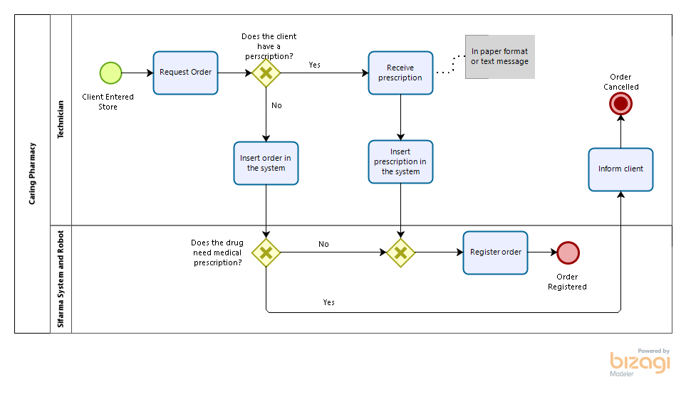

Figure 30- Receive Client TO-BE Model

|  |  |  |  |  |  |  |  |  |
| --- | --- | --- | --- | --- | --- | --- | --- | --- |
| Name | Type | Instances completed | Instances started | Minimum time | Maximum time | Average time | Total time | Total time waiting resource |
| Caring Pharmacy | Process | 211 | 220 | 24s | 2m12s | 1m38s | 5h45m55s | 24s |

Figure 31 - Receive Client Simulation Results

|  |  |
| --- | --- |
| Resource | Utilization |
| Technician | 16,95% |
| Sifarma System | 4,35% |

Figure 32 - Receive Client Resource Utilization

The heuristics used to model this TO-BE process:

* **Task Elimination:** we reduced the non-value-adding steps, like handovers and checks, to the minimum.
* **Automation:** by implementing an information system (Sifarma System), we replaced the physical flow with information flow, avoided duplication of data entry and transportation. The order and prescription are inserted in the system the right way and there is no need for the technician to check if the drugs ordered need a prescription, the system does it for him. If the customer has a prescription or if the drugs ordered do not need one, the order is automatically registered in the system.

With the help of the Devil’s Quadrangle, we concluded that: the time improved; the cost might increase with the adoption of the System, nonetheless after some time the return will be easily achieved; the quality increased due to the reduction of human errors; and, in terms of flexibility it decreased because it is harder to change the system behavior.

Enter and Check Prescription

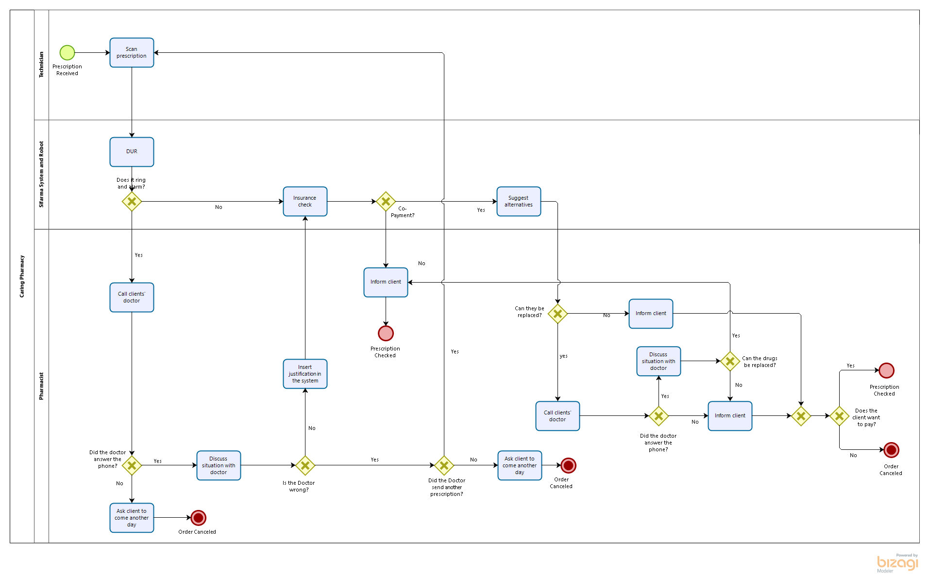

Figure 33 - Enter and Check Prescription TO-BE Model

|  |  |  |  |  |  |  |  |  |
| --- | --- | --- | --- | --- | --- | --- | --- | --- |
| Name | Type | Instances completed | Instances started | Minimum time | Maximum time | Average time | Total time | Total time waiting resource |
| Caring Pharmacy | Process | 100 | 176 | 18s | 8m22s | 3m23s | 5h39m51s | 3m58s |

Figure 34 - Enter and Check Prescription Simulation Results

|  |  |
| --- | --- |
| Resource | Utilization |
| Pharmacist | 19,51% |
| Technician | 0,92% |
| Sifarma System | 9,79% |

Figure 35 - Enter and Check Prescription Resource Utilization

The heuristics used to model this TO-BE process:

* **Automation:** using the new information system (Sifarma System) to include the Drug Utilization Review, insurance check, and suggestion of alternatives all in one system.
* **Task Elimination:** reduced the non-value-adding steps and eliminate the checks, that are now being done by the system.

With the help of the Devil’s Quadrangle, we concluded that: the time improved; the cost might increase with the adoption of the System, nonetheless after some time the return will be easily achieved; the quality increased due to the reduction of human errors; and, in terms of flexibility it decreased because it is harder to change the system behavior.

Fulfill Order

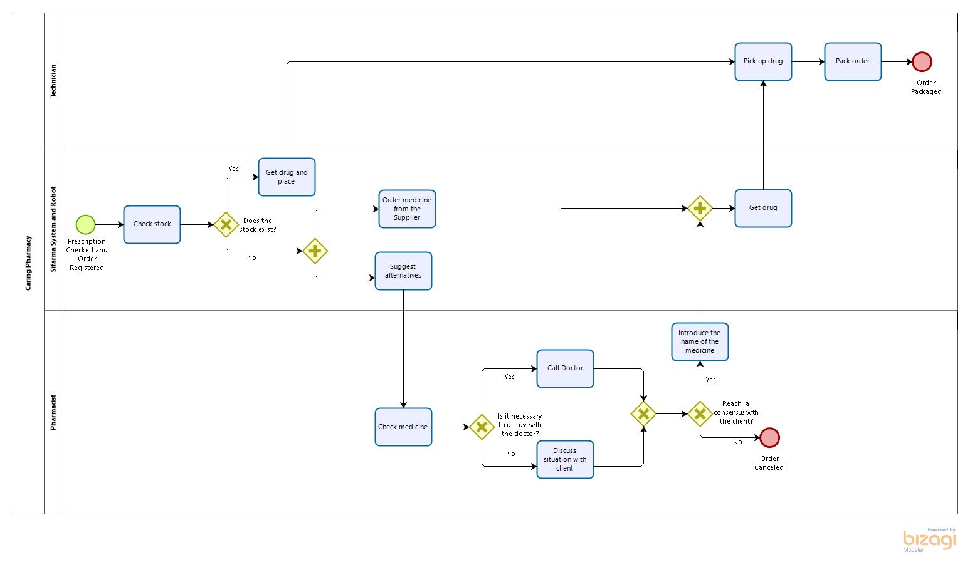

Figure 36 - Fulfill Order TO-BE Model

|  |  |  |  |  |  |  |  |  |
| --- | --- | --- | --- | --- | --- | --- | --- | --- |
| Name | Type | Instances completed | Instances started | Minimum time | Maximum time | Average time | Total time | Total time waiting resource |
| Caring Pharmacy | Process | 162 | 189 | 24s | 6m18s | 51s | 3h54m52s | 12m |

Figure 37 - Fulfill Order Simulation Results

|  |  |
| --- | --- |
| Resource | Utilization |
| Pharmacist | 9,28% |
| Technician | 3,15% |
| Sifarma System | 9,73% |

Figure 38 - Fulfill Order Resource Utilization

The heuristics used to model this TO-BE process:

* **Task Elimination:** we reduced the non-value-adding steps, like handovers and checks, to the minimum.
* **Automation:** by implementing an information system with a pharmaceutical robot (Sifarma system) tasks that were done by the technician and pharmaceutic will be done by the system more quickly and without the need for checking and confirming, because of the error rate of the system is really low. The tasks like checking the stock, get the drugs, order drugs when in need, find alternatives, will all be done by the system. This way the employees can focus on the customer and improve client satisfaction.
* **Parallelism Enhancement:** tasks that were done sequentially, will be done in parallel, like suggesting other drugs and order from the supplier the drugs that are missing, when there is no stock of the drugs prescript.

With the help of the Devil’s Quadrangle, we concluded that: the time improved, once some unnecessary tasks were deleted and some tasks started being performed in parallel; the cost might increase with the adoption of the System, nonetheless, after some time the return will be easily achieved; the quality increased due to the reduction of human errors; and, in terms of flexibility it decreased because it is harder to change the system behavior.

Deliver and Payment

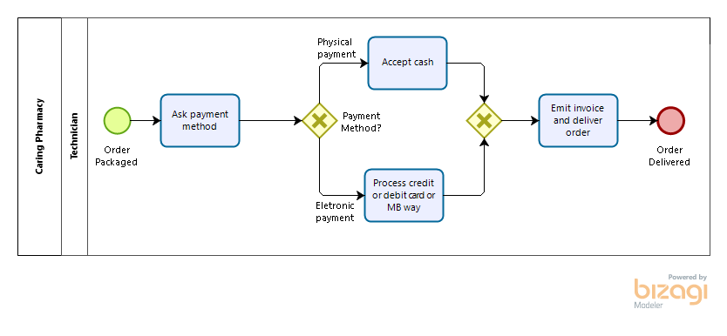

Figure 39 - Deliver and Payment TO-BE Model

|  |  |  |  |  |  |  |  |  |
| --- | --- | --- | --- | --- | --- | --- | --- | --- |
| Name | Type | Instances completed | Instances started | Minimum time | Maximum time | Average time | Total time | Total time waiting resource |
| Caring Pharmacy | Process | 162 | 162 | 29s | 1m11s | 50s | 2h15m34s | 0 |

Figure 40 - Deliver and Payment Simulation Results

|  |  |
| --- | --- |
| Resource | Utilization |
| Technician | 6,89% |

Figure 41 - Deliver and Payment Resource Utilization

The heuristics used to model this TO-BE process:

* **Triage:** in the payment, specify the payment methods, including the option to pay using contactless methods (due to the current pandemic situation).
* **Task Composition:** emit the invoice and give the package to the client, all at once.

With the help of the Devil’s Quadrangle, we concluded that for this sub-process: the time worsen, once we specified more options of methods of payment; the cost might decrease; the quality will not be affected; and, in terms of flexibility it improves.

# Implementation Plan

To perform at its fullest some adjustments need to be made:

* Confirm the most important steps of the order in different stages to avoid errors and mistakes.
* Full integration of the system in the robot.
* Employee training to ensure that the employees take full advantage of the system and robot.
* Make sure that the system and robot are kept updated.
* To better manage the queue, we recommend a ticket queue management system.

# Limitations

This project suffers from limitations that are out of our teams' control, we are restricted by the lack of possibility to contact the pharmacy in case of doubts having only one source of information about the pharmacy’s processes, the project description pdf provided by the teachers'. This limitation forced us to make assumptions about the business processes that could have, otherwise, been confirmed by the pharmacy.

As master students at Nova IMS, our team was limited in terms of area of business knowledge, the pharmacy field is one in which everyone from our team lacks knowledge in and therefore all business decision was taken based only on research done by us, so one can assume if someone with more experience in this area was hired, he could potentially bring more insights.

We consider the price a decisive factor and since we did not had access to it when we suggested the SIFARMA we only considered the capabilities, not being able to compare if the investments were worth it compared to other pharmacy management systems.

The simulation tool itself, in Bizagi, has some limitations because the simulations results are only as trustworthy as the input data and rely a lot on our ‘guesstimates’, the models are always followed to the letter with no derivations and no workarounds, the assumption that there is no multi-tasking, and the resources work constantly and non-stop.

# Conclusion

While analyzing the four subprocesses of Caring Pharmacy, we were able to understand the internal operations of the pharmacy, in terms of events, activities, decisions, and actors. Then we designed an AS-IS model of the process, to have a visual representation of these.

After it, we performed a qualitative analysis, and some issues were identified. To overcome those problems and eliminate the wastes raised, by performing a value-added analysis, waste analysis, and completing an issue register, we designed the TO-BE Model to reach the best business process model.

In the solution presented, we decided to automatize the process by adding a Sifarma System and a Rowa Vsmart (a robot that manages the stock automatically) since it can help on the tasks that did not need human intervention. It is noteworthy to mention that the time variable improved in three out of four sub-processes, and the quality variable improved in all of them. Hence, we concluded that these implementations in the pharmacy would increase costs in a short time but will increase the profit in the long term.

The redesign of the processes we suggested brings efficiency to all of them, emerges quality benefits with less error rate, increases customer satisfaction along with fewer queues, and reduces the total time between the client ordering and receiving the order package.